

Project Initialization and Planning Phase

Date | 02 July 2024
Team ID | SWTID-2026-9778
Project Name | Credit Card Approval Prediction
Maximum Marks | 3 Marks

Define Problem Statements (Customer Problem Statement Template):
A Credit Card Approval Prediction System helps financial institutions automatically evaluate credit card applications based on customer details such as income, employment status, credit score, loan history, age, and financial behavior. This reduces manual effort, improves accuracy, minimizes fraudulent approvals, and speeds up the decision-making process while providing a better customer experience..

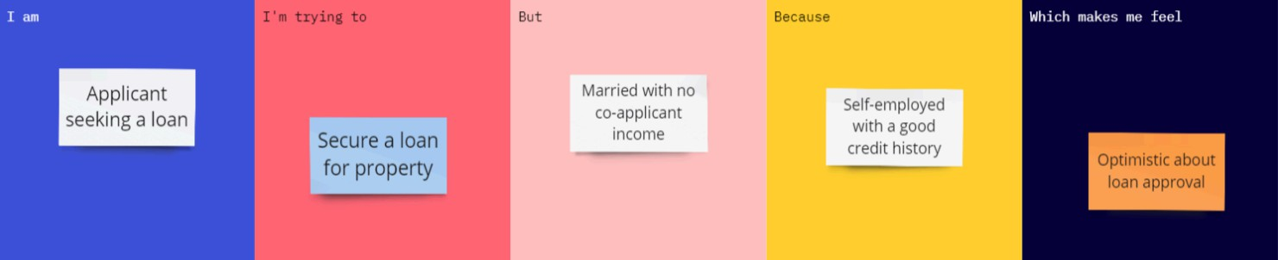
Example:
